Day 3 Java and DSA

Matrix Addition:
import java.util.*;
class Matrix{
public static void main(String[] args){
Scanner sc=new Scanner(System.in);
System.out.println("Enter the number: ");
int n=sc.nextInt();
int[][] arr1=new int[n][n];
int[][] arr2=new int[n][n];
int[][] res=new int[n][n];
System.out.println("Enter the element for arr1: ");
for(int i=0;i<n;i++){
for(int j=0;j<n;j++){
arr1[i][j]=sc.nextInt();
}
}

System.out.println("Enter the element for arr2: ");
for(int i=0;i<n;i++){
for(int j=0;j<n;j++){
arr2[i][j]=sc.nextInt();
}
}

for(int i=0;i<n;i++){
for(int j=0;j<n;j++){
res[i][j]=arr1[i][j]+arr2[i][j];
}
}
System.out.println("Sum of two matrix is : ");
for(int i=0;i<n;i++){
for(int j=0;j<n;j++){
System.out.print(res[i][j]+" ");
}
System.out.println();
}
}
}

Output:
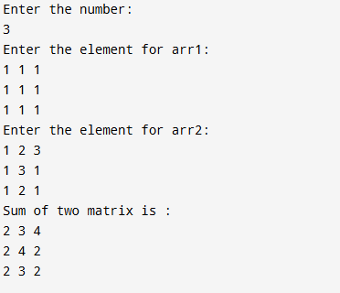

Transpose Matrix:
import java.util.*;
class Matrix{
public static void main(String[] args){
Scanner sc=new Scanner(System.in);
System.out.println("Enter the number: ");
int n=sc.nextInt();
int[][] arr1=new int[n][n];
System.out.println("Enter the element for arr1: ");
for(int i=0;i<n;i++){
for(int j=0;j<n;j++){
arr1[i][j]=sc.nextInt();
}
}
System.out.println("old matrix : ");
for(int i=0;i<n;i++){
for(int j=0;j<n;j++){
System.out.print(arr1[i][j]+" ");
}
System.out.println();
}
System.out.println("new matrix : ");
for(int i=0;i<n;i++){
for(int j=0;j<n;j++){
System.out.print(arr1[j][i]+" ");
}
System.out.println();
}
}
}

Output:
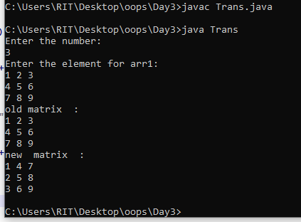

Spiral Matrix:
Code:
import java.util.*;
class Spi{
public static void main(String[] args){
Scanner sc=new Scanner(System.in);
System.out.println("Enter the number: ");
int n=sc.nextInt();
int[][] arr=new int[n][n];
System.out.println("Enter the element for arr1: ");
for(int i=0;i<n;i++){
for(int j=0;j<n;j++){
arr[i][j]=sc.nextInt();
}
}
int top=0;
int bottom=n-1;
int left=0;
int right=n-1;
while(top<=bottom && left<=right){
for(int i=left;i<=right;i++){
System.out.print(arr[top][i]);
}
top++;
for(int i=top;i<=bottom;i++){
System.out.print(arr[i][right]);
}
right--;
for(int i=right;i>=left;i--){
System.out.print(arr[bottom][i]);
}
bottom--;
for(int i=bottom;i>=top;i--){
System.out.print(arr[i][left]);
}
left++;
}
}
}
Output:
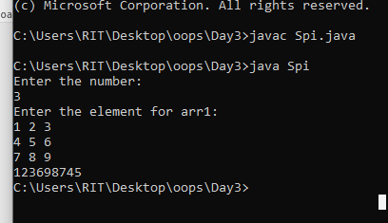
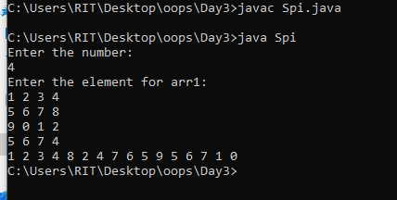

Saddle Point:
Code:
import java.util.*;
class Spi{
public static void main(String[] args){
Scanner sc=new Scanner(System.in);
System.out.println("Enter the number: ");
int n=sc.nextInt();
int[][] arr=new int[n][n];
System.out.println("Enter the element for arr1: ");
for(int i=0;i<n;i++){
for(int j=0;j<n;j++){
arr[i][j]=sc.nextInt();
}
}
boolean found=false;
for(int i=0;i<n;i++){
int min=0;
for(int j=1;j<n;j++){
if(arr[i][j]<arr[i][min]){
min=j;
}
}
boolean saddle=true;
for(int k=0;k<n;k++){
if(arr[k][min]>arr[i][min]){
saddle=false;
break;
}
}
if(saddle){
System.out.println("Saddle Point :"+arr[i][min]);
found=true;
break;
}
}
if(!found){
System.out.println("no saddle point");
}
}
}

Output:
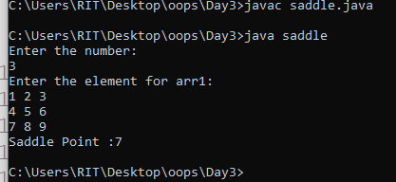
Pattern 1:
Code:
import java.util.*;
class pat{
public static void main(String[] args){
Scanner sc=new Scanner(System.in);
int n=sc.nextInt();
for(int i=1;i<=n;i++){
for(int j=1;j<=n-i;j++){
System.out.print(" ");
}
for(int k=1;k<=i*2-1;k++){
System.out.print("*");
}
System.out.println();
}
}
}

Output:

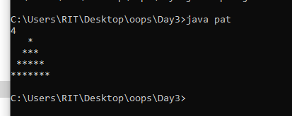

Hallow Pattern:
Code:
import java.util.*;
class hallow{
public static void main(String[] args){
Scanner sc=new Scanner(System.in);
int n=sc.nextInt();
for(int i=1;i<=n;i++){
for(int j=1;j<=n-i;j++){
System.out.print(" ");
}
for(int k=1;k<=i*2-1;k++){
if(k==1||k==i*2-1||i==n){
System.out.print("*");
}
else{
System.out.print(" ");
}
}
System.out.println();
}



